Political Juggernauts: A Quantitive Analysis Of Candidates in the 2019 Lok Sabha Elections

1.INTRODUCTION:

1.1 OVERVIEW:

In This Project we are briefly analysis about the candidates who participated in the 2019 lok sabha elections. The Lok Sabha is composed of representatives of people chosen by direct election on the basis of Universal Adult Suffrage. The Constitution of India allows for a maximum of 550 members in the House, with 530 members representing the States and 20 representing the Union Territories. The 17th Lok Sabha was formed by the members elected in the 2019 Indian general election. Elections, all across India, were conducted in seven phases from 11 April 2019 to 19 May 2019 by the Election Commission of India.

The Bharatiya Janata Party received 37.36% of the vote, the highest vote share by a political party since the 1989 general election, and won 303 seats, further increasing its substantial majority. In addition, the BJP-led National Democratic Alliance (NDA) won 353 seats.

1.2 PURPOSE:

From this project we can see a clear analysis about everything In detalils about the candidates in 2019 lok sabah elections,some key analysis are given below ;

\*state wise winners,party wise winners \*genter and educational wise general vote \*state wise general votes and postal votes \*state wise criminal cases \*consistuency wise winners and electors \*winners by education and category \*party wise postal votes

2.PROBLEM DEFINITION &DESIGN THINKING:

2.1 EMPATHY MAP: 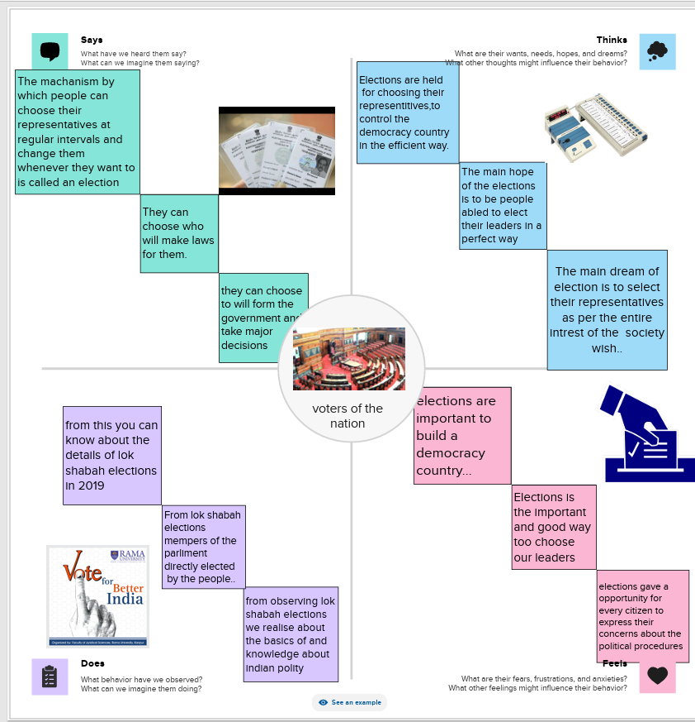

2.2 IDEATION&BRAINSTROMING MAP:

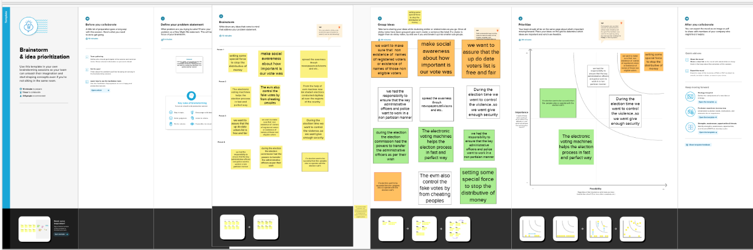

3.RESULT

DASHBOARD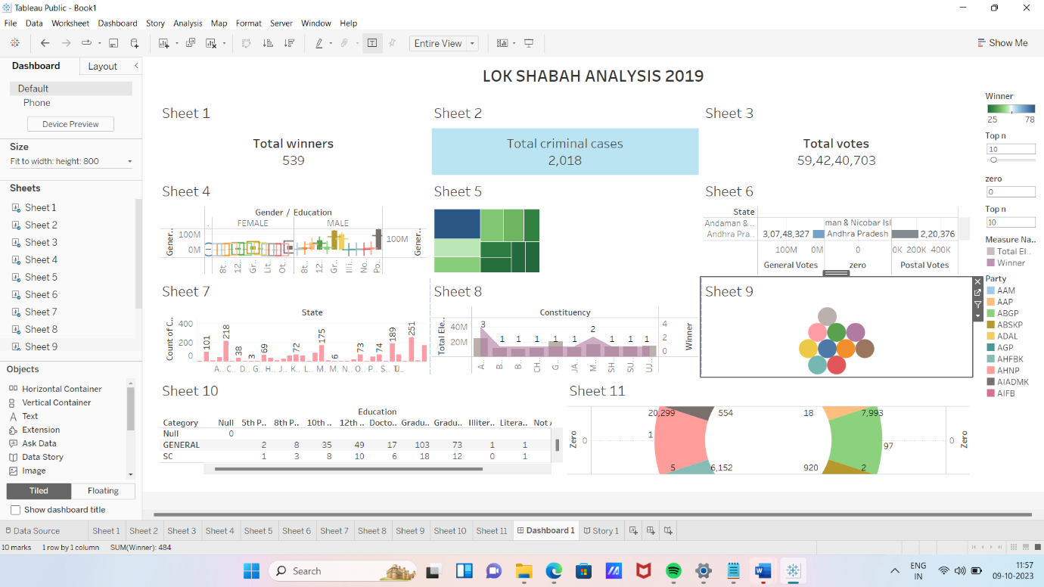

STORY: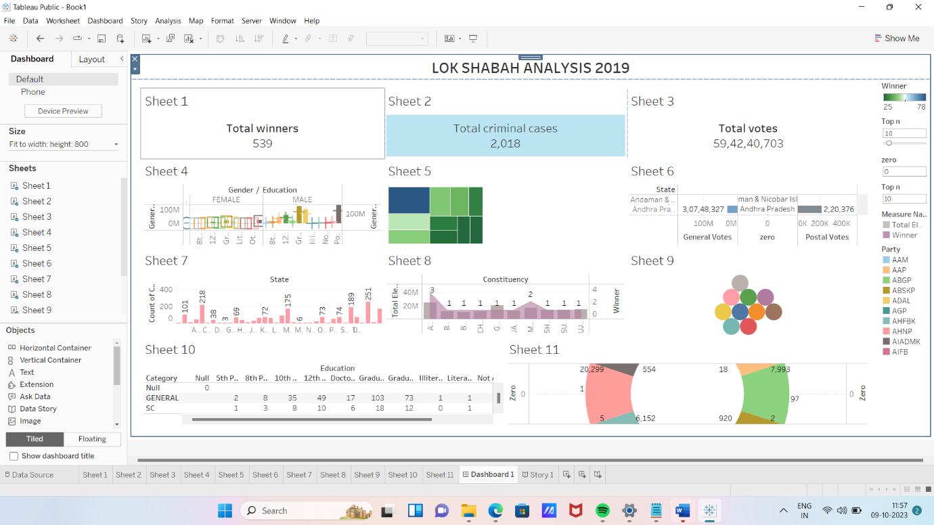

4.ADVANTAGES

\*Quantitive analysis provides objective data driven insights into the electoral process,reducing the influence of personal biases and opinions

\*charts,graphs,and tables can be used to present complex data in a visually accessible manner,making it easier for stakeholders to grasp the findings

\*it’s a time efficient way to process and analyze a large volume of data,especially when dealing with nationwide elections.

Disadvantages;

\*Quantitive analysis may oversimplify political and social issues ,potentially missing important context

\*The use of sensitive personal information like criminal records or financial data ,raises ethical concerns about privacy and data security

5.APPLICATIONS;

\* Journalists can use the data and insights to enhance their reporting on elections,providing readers with a deeper understanding of candidate profile

\*Educational institutions can use the analysis to teach the students about the complexities of electoral politics ,data analysis,and civic engagement

6.Conclusion;

Political juggernauts contributes to the ongoing discourse on Indian politics and underscores the importance of data driven analysis in understanding and improving the democratic process.

7.Future scope;

It is our hope that the insights gained from this study will continue to inform discussions,policies and actions aimed at strengthening India’s democratic institutions and ensuring a more inclusive and accountable political landscape for the future.